THE BIG BIRTHDAY

COMPETITION

APPLICATION FORM

1. PERSONAL DETAILS
Several people can apply together. Please state the personal details of each applicant.

Full Name:

Company Name (if applicable):

Phone Number:

E-mail:

Website:

2. PROJECT DESCRIPTION – MAX. 1 PAGE

Title :

Description :

3. PROJECT PLANNING
Use this page to show us how you would like to plan your event and use The Vaults. You can either draw directly onto the map below, or you can print this page, make the required amendments, and post your application to us.

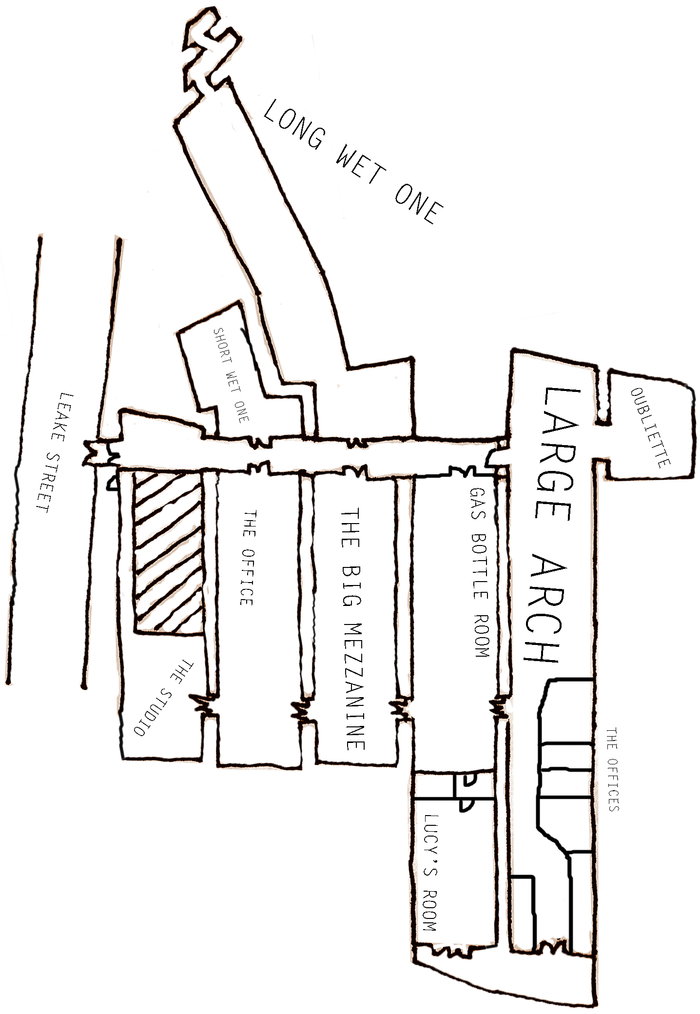

4. LIST OF THE ARTISTS AND/OR ART WORKS YOU MIGHT WANT TO SHOWCASE OR WORK WITH (OPTIONAL)
This can be e.g. the title of a book, a movie, or the name of a band.

5. LIST OF ATTACHED DOCUMENTS TO COMPLETE YOUR PROJECT DESCRIPTION (OPTIONAL)
You can attach pictures or/and a video to your application.

Applications can be sent by e-mail to enquiries@the-vaults.org, or by post, to:
The Vaults
Number 153
88 Lower Marsh
Waterloo
London
SE1 7AB

All applications must be submitted before Sunday 9th March.

All the information and materials you provide us are for an internal use only. None of them will be used by The Vaults, unless you allow us to do so at a later stage.

